


Royal University of Bhutan
Jigme Namgyal Engineering College
Dewathang, Bhutan

Lab report on DNS Server Configuration
Module Name: Linux Network Services Administration
Module Tutor: Mr. Tashi Tobgay
Submitted by: Kinley Nidup
Student Number: 05230119

Introduction
The Domain Name System (DNS) is a hierarchical and decentralized naming system used for translating human-friendly domain names (like www.example.com) into machine-readable IP addresses (such as 192.168.1.1). This system is crucial for the functioning of the internet as it allows users to access websites using easy-to-remember names rather than numeric IP addresses.

DNS operates through a network of servers that work together to resolve queries, making it a distributed database for domain names and their corresponding IP addresses. It uses various protocols to ensure queries are handled efficiently and accurately, enabling users to access resources quickly.

Network Topology

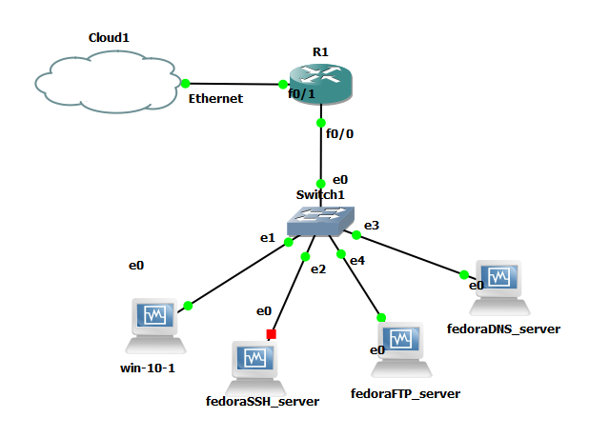
Figure 1 Network Topology

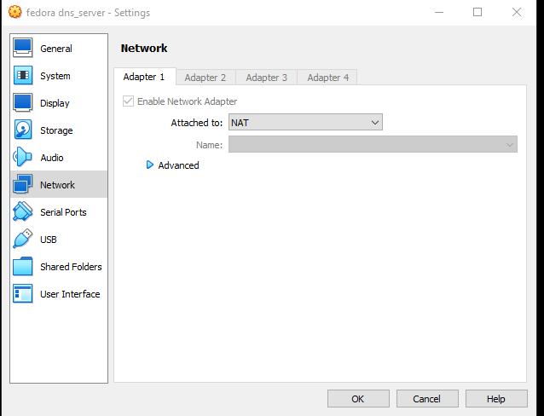
Figure 2 change the network to NAT

Step 1 Update Package Repository
First, make sure your system packages are up to date.
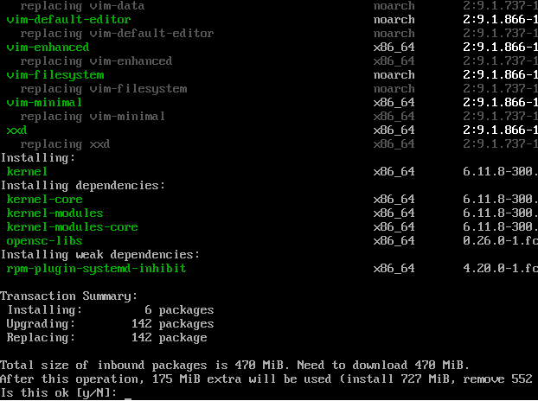
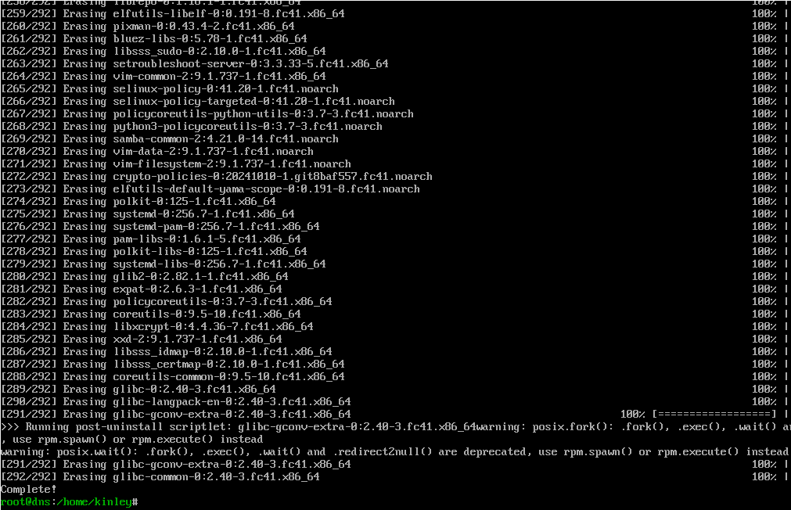
Figure 3 update dnf
Strep 2 Install BIND and Related Tools
Install BIND (named) and other necessary tools.
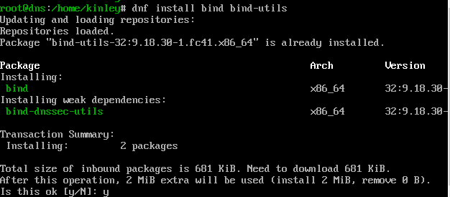
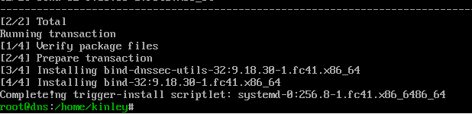
Figure 4 install bind and related tools
Step 3 Install Vim
Run the following command to install Vim.
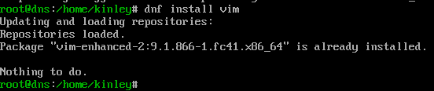
Figure 5 Install vim

Step 4 Modifying the Main Configuration File (named.conf)
The main configuration file for BIND is located in the /etc/ directory and is named named.conf. This file controls how the BIND server operates, including the zones it will serve. When setting up your DNS server, you'll need to make specific modifications to this file to define your domain zones and other necessary parameters.
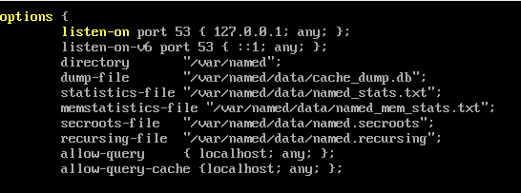
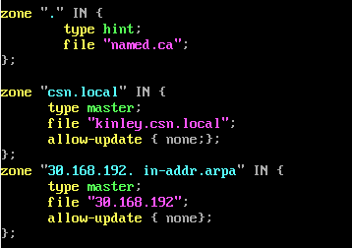
Figure 6 Verifying file(named.conf)

Step 5 Creation of Forward Lookup Zone File
After defining the zones in the named.conf file, the next step in setting up your DNS server is to create the zone files that contain the DNS records. For the forward lookup zone, we will create a file named kinley.csn. local in the /var/named directory, as specified in your configurations.
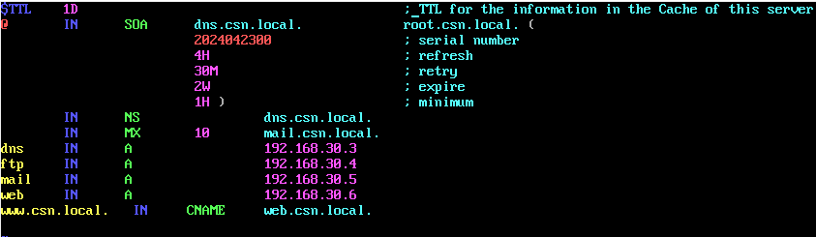
Figure 7 configure forward lookup zone file

Step 6 Creation of Reverse Lookup Zone File
After setting up the Forward Lookup Zone file, the next step in configuring your DNS server involves creating a Reverse Lookup Zone file. This file will allow clients to perform reverse DNS lookups, mapping IP addresses back to their associated domain names. The reverse lookup zone file will be named 30.168.192 and will be created in the same directory as the forward lookup zone file: /var/named.
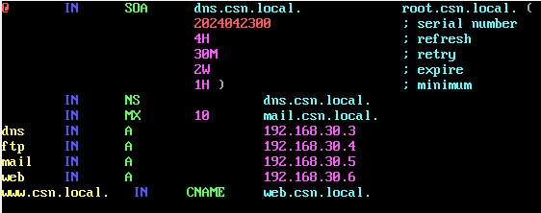
Figure 8 configure revers lookup zone file
Step 7 Starting and Enabling the named Service:
Once the zone files for both forward and reverse lookups have been successfully created and configured, the next step in setting up your DNS server is to start the named service, which is the BIND DNS server daemon. Additionally, enabling the service ensures that it starts automatically on system boot, allowing your DNS server to be operational without manual intervention.
Figure 9 Starting and Enabling the named Service
Step 8 Verify the Service Status
After starting the service, you should verify that it is running as expected. To check the status of the named service.
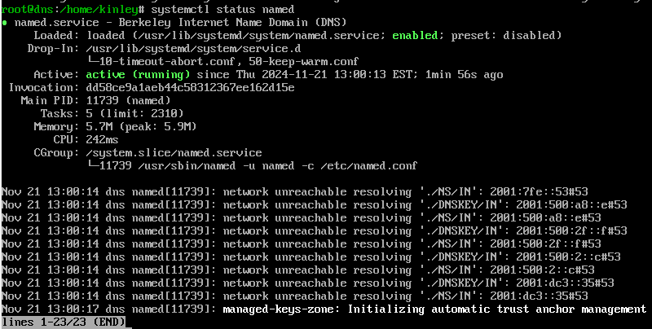
Figure 10 verify the service status

Step 9 Configure firewall
To ensure the proper functioning of the BIND DNS server, it is essential to configure both network and host firewalls to allow incoming traffic on port 53, which is used for DNS queries. DNS operates primarily over two transport protocols: TCP and UDP. Understanding the role of each in DNS operations is crucial for effective firewall configuration.

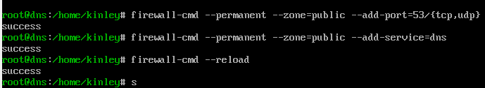
Figure 11 configure firewall

Check the connection between the dns server and the router
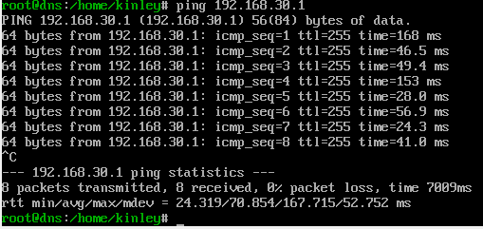
Figure 12 check connection

Step 10 Assign static ip address to the client
To assign a static IP address to a client, first access the network settings on the client device after configuring the network appropriately. Select the network adapter in use, then choose the option to manually configure the IP settings. Enter the desired static IP address, ensuring it is within the same subnet as your network but outside the range of the DHCP lease pool. Additionally, input the subnet mask, default gateway, and preferred DNS servers.

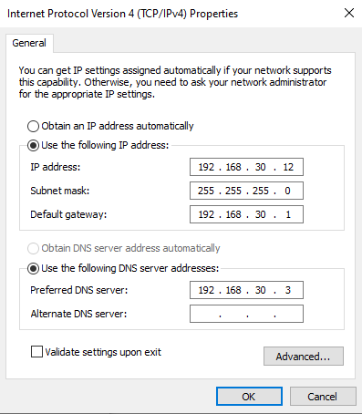
Figure 13 assign static ip address

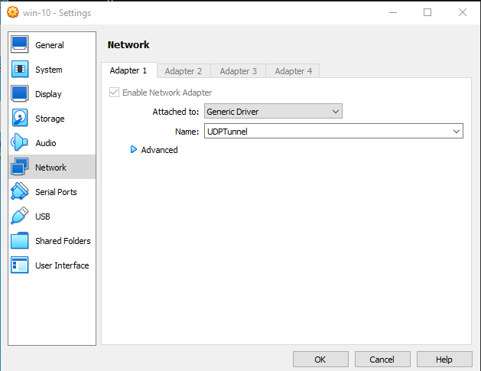
Figure 14 change the network in window client

Step 11 Ping server and router from client
To check connectivity between a client, a server, and a router, you can use the "ping" command, which is a network utility used to test the reachability of a host on an Internet Protocol (IP) network.

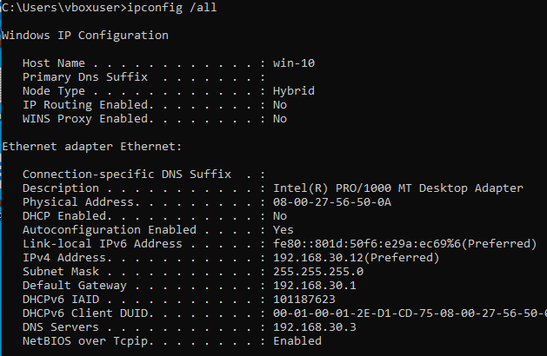
Figure 15 Client ip address
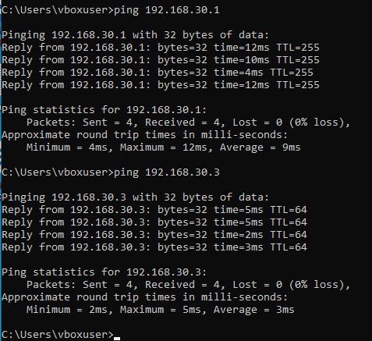
Figure 16 ping to router


Figure 17 ping to dns server

Step 12 Enter the domain name in window client
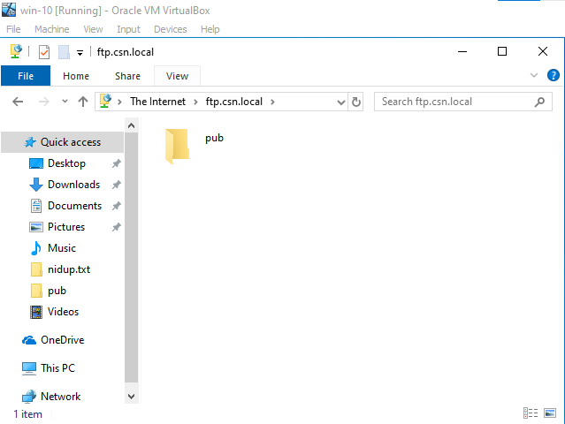
Figure 18 pub directory was shown in client
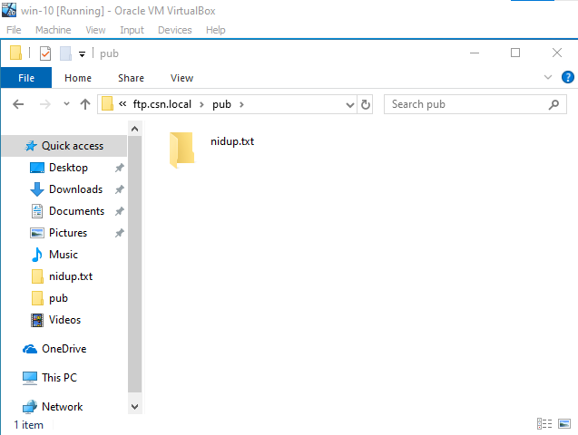
Figure 19 shown nidup.txt file

